**EXPLORE WEATHER TRENDS**

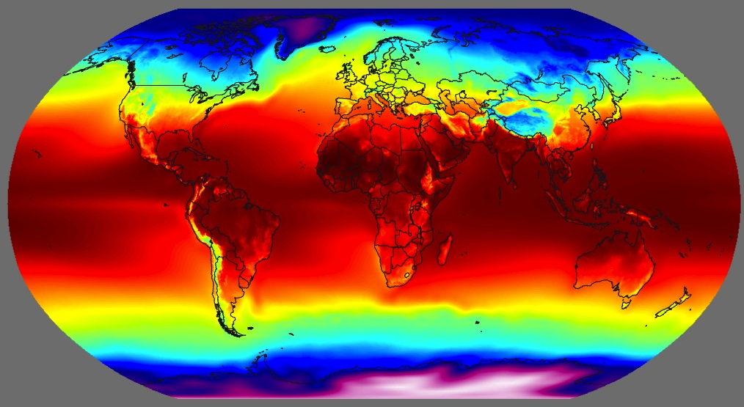

DATA ANALYST NANO DEGREE PROGRAM

PROJECT 1

SUBMITTED BY

**SHILPA PONNATHOTA**

WINSOR, CANADA

**PROJECT GOAL:**

The goal of the project is to analyze the global temperature and the local temperature and compare the temperature trends between the both.

**TOOLS USED:**

I have used the **SQL** for extracting the data and **MS EXCEL** to analyze and compare both the data using a line chart.

**PROJECT PROCEDURE:**

STEP 1: EXTRACTION

There are three data sets present in the SCHEMA namely global_data containing the average temperature all over the world, city_list containing the list of the cities and the city_data containing the average temperature of the cities.

* The global data is extracted using the below SQL statement in the given work space and the csv file is downloaded by clicking the icon on the right side of the screen.

Command:

SELECT *

FROM global_data ;

* The closest city to me is found by giving the following command. From the output I have chosen LONDON since it is the closest city to me.

command

SELECT *

FROM city_list

WHERE country = 'Canada’ ;

* The average temperature of the London city is extracted in SQL by typing in the following command and the csv file is obtained by clicking on the download csv button.

Command

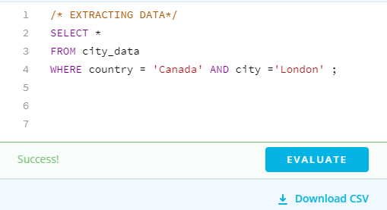

STEP 2: OPEN CSV FILE

The csv files of London and global temperatures are opened in the Excel spread sheet.

STEP 3: DETERMINING THE MOVING AVERAGES

As per learnt in the udacity course, the moving average is calculated for both the average temperature of London and global values by using the average( ) function for the first ten entries and dragging the formula down till the last entry cell.

Here, I have taken the moving averages for every ten years, since decade will be normally a standard period.

There were certain data missing in London between 1746 to 1749 and the data were present from the year 1743 to 2013. The data in the global temperature data set was present between 1750 to 2015.

So, Commonly I have analysed the data from 1750 to 2013 in moving average of decades.

STEP 4: CREATING A LINE CHART

The moving averages of both global and London temperatures are copied to the same spread sheet and the line chart is plotted with year on horizontal axis and the average temperatures in degree Celsius in vertical axis.

The global temperature variations are shown in blue line and the London average temperature variation is shown in orange line.

Fig: line chart representing the weather trends -global vs local

**OBSERVATIONS**

* The global average temperature varies from 7.9 to 9.5 degree Celsius and the average temperature of the London has varied from 6.97 to 9.3 degree Celsius through the period of 1750 to 2013.
* The average temperature of the London has been less than the global temperature in most of the times. But in 1809-1812 the temperature difference was very less. So, the London is cooler than the overall temperature.
* The average global temperature had less fluctuation when compared to the London temperature and the fluctuations for both between 1809 to 1829 and it was steady increase started from late 1980’s. In between these periods the temperature was fluctuating between 7.8 to 8.3 celsius approx.
* Both the average temperatures have consistently gone up after 1989 showing that the world is getting hotter.
* Over the last few decades, the world and london has got hotter than ever.

**CONCLUSION**

The world is getting hotter year by year showing significantly that global warming is happening at a fast rate.